***Individual Media Reflection***

***Movie – “Dark Waters” (2019 directed by Todd Haynes)***

**Maksat Mametjumayev**

**BUS – 355 – BOS 1**

**Professor: Dr. Shelley F. Mitchell**

***March 31, 2022***

**Table of Contents**

Write a few words about the film.……………………………………………………................​1.1

Describe the plot and the main characters (Briefly)…..………………………………………...​1.2

Identify the main ethical issues.………………………………………………………………...​1.3

Examine the behavior of the main actors based on the theories discussed in class….….…...…​1.4

Write your opinion and feelings about the film…………………………………………………...​2.1

What impact did the film have on you.……………….………………………………………...​2.2

How do you judge the behavior of the main characters...……………………....………………​2.3

Media Question One...…………………………………………………………………….…...​3.1

Media Question Two...………….…………....…………………………………….………….​3.2

Media Question Three...……………………………………………....……………………….​3.3

Bibliography.………………...………………………………………………………………...4.1

* 1. Write a few words about the film

The movie “Dark Waters” is based on a real story which is about the long environmental lawsuits between a corporate attorney and one of the largest American chemical companies, DuPont Corporation. The purpose of these environmental lawsuits was to unhide the lengthy history of the pollution by DuPont that negatively affect the life of the local communities in West Virginia. Hence, several serious ethical issues of DuPont are discussed in the movie.

* 1. A poster of a group of people

     Description automatically generated with medium confidenceDescribe the plot and main characters.

|  |  |
| --- | --- |
| Robert Bilott  (Known as Rob in the movie) | The corporate defense attorney of Taft law firm in Cincinnati city of Ohio. |
| Sarah Barlage Bilott | Rob’s wife |
| Tom Terp | CEO of Taft’s law firm |
| Wilbur Tennant | A farmer from Parkesburg, West Virginia, and acquaintance of Rob’s grandmother |
| Jim Tennant | Wilbur’s brother and he used to dig ditches for DuPont |
| Phil Donnelly | DuPont’s lawyer |
| Dr. Gillespie | Chemical expert who gave information about PFOS to Rob which is similar to PFOA |
| Dr. Karen | Science panelist who identified the six categorized diseases associated with PFOA |
| Joe Kiger | A Potential Plaintiff of Taft law firm on behalf of the 70,000 residents, whose water Dupont knowingly poisoned for 40 years. He was a physical education teacher in Parkesburg, West Virginia |

The movie opens its main point when Wilbur came to meet with Rob to request him to defend against DuPont as the company’s pollution caused his animals’ death. Wilbur said that he was an acquaintance of his grandmother who lived in Parkesburg, West Virginia while he handed the boxes of videotapes that show evidence. Rob drove to Parkesburg, West Virginia to meet his grandmother and talk about Wilbur. In the beginning fragments of the movie where her grandmother shows the photos, during his childhood, Rob used to spend his time on the farm next to Wilbur’s. Afterward, he drove to Wilbur’s farm for exploring his situation he saw the body types of his dead cow. Wilbur claimed that they could be signs of a bizarre disease. Then he took Rob to show the river, specifically the white stones, and stated that it is bleached. The animals of his farm drank the water from this river and as consequence, they got bloody welts and dead eyes. Wilbur’s statement grabbed Rob’s attention and asked- “where the rest of the cows are?” when he saw two cows nearby the river. Wilbur took Rob to the field where 190 cows were buried. Rob was shocked.

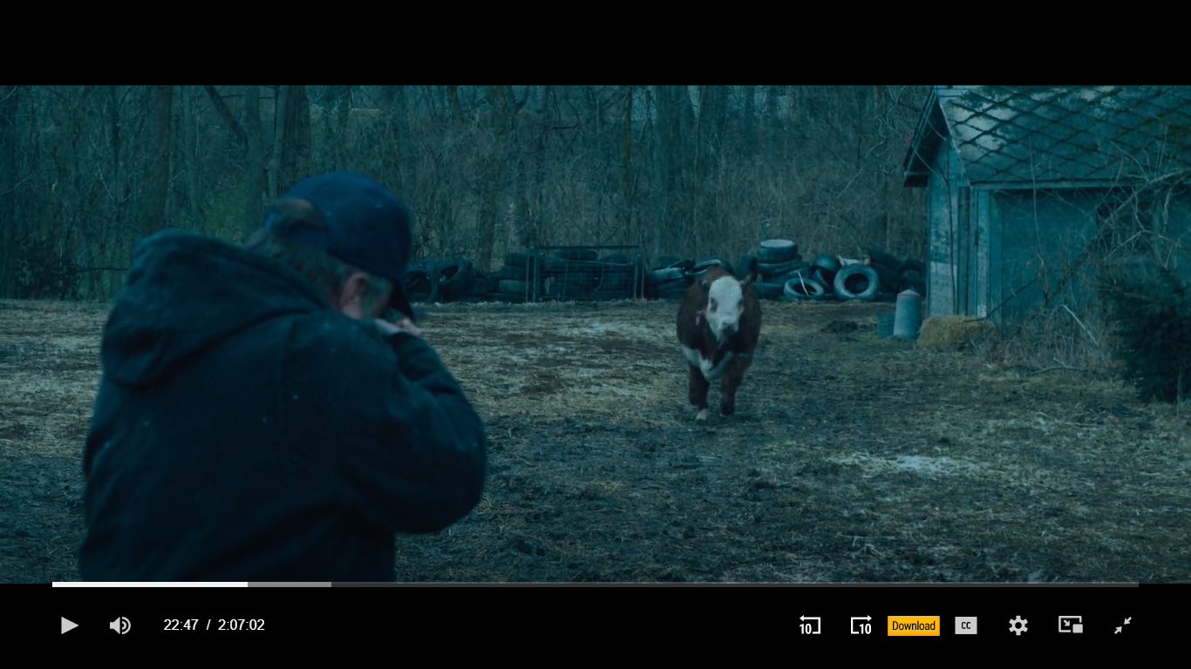From Wilbur, Rob asked another intrigued question about the landfill he saw. Wilbur claimed that Jim used to dig ditches for DuPont which triggered his sickness and its discontinuation. According to Wilbur’s response, DuPont offered Jim to purchase his place and promised not to chemical dump. Noticeably, their promise was not reliable. As well, Wilbur mentioned that his dozens of calls to DuPont, State, and Federal government organizations were not answered, even he was not able to see the report that was written by Environmental Protection Agency (EPA). However, Rob received this report after having a conversation with Phil Donnelly, DuPont’s lawyer, during the dinner with Taft lawyers. Then, he read the findings from a report by EPA to Wilbur which made him furious. Meanwhile, one of the cows nearby them were aimed to hit them because of the dizziness. Wilbur grabbed his gun and shot. This situation scared Rob and gave him reason to think about defending Wilbur. Eventually, Rob decided to defend Wilbur against DuPont. He showed Wilbur’s videotapes to Tom to get permission to sue DuPont. Tom unwillingly permitted to take the case as Rob promised it will be a small side job. From there a lengthy environmental lawsuit fight against DuPont starts.

1.3 Identify the main ethical issues.

When Robert was able to legally get documents PFOA from DuPont, a hundred boxes of documents were brought to Taft with the purpose to complicate his work. Nevertheless, Rob went through these files one by one and started unhiding the main ethical issues of Dupont- lengthy pollution, manipulation, and hiding the research results, pressuring the plaintiffs.

Going through the files, Rob found out information about the “PFOA” is also known as “PFOA-C8” or just “C-8”. According to the chemical expert, Dr. Gillespie, it might be similar to “PFOS” which is a long-chain fluorocarbon synthetic and it is unbreakable. Rob asked what if the person drinks it. Dr. Gillespie smiled and responded that it would be similar to swallowing a tire. Suddenly, Rob remembers the biking girl in Parkesburg whose teeth were black and called Dr. Gillespie to ask this question again but specifying what will happen to the teeth if they drink it. He answered that it can be stuck and turn the teeth black. So, Rob discovered that PFOA-C8 is a man-made chemical used in the production of Teflon. Before it was used for army tanks and saw that a secret study of the DuPont about PFOA-C8 on the rabbits, and its employees can be the reason for cancer, birth defects in babies. He was so upset and was trying to get rid of the positioned items in the kitchen at night. The noise made his wife Sarah to woke and made him explain his action. He told his findings of PFOA-C8 to Sarah, Wilbur, Tom, and Phil accusing of DuPont hiding these findings which is one of the ethical issues created by DuPont.

Moreover, DuPont knowingly polluted the environment for 40 years by releasing its dust into the air. Additionally, tossing the sludge into Ohio, or packing in drums started washing up and caused the digging of the ditches on Washington where they dumped thousands of chemical sludges and dust. Afterward, he sent evidence to the EPA, Justice Department, and so on. As a result, DuPont was fined $16.5 million by the EPA which proves another of DuPont’s ethical issues.

Furthermore, in the movie when Wilbur’s home was in chaos and he claimed that DuPont came to steal the evidence like dead body types of his cows. Then he saw the helicopter and shouted to them to leave his property. Also, when Rob was engaged in a business conversation with Phil Donnelly about “PFOA” at “Ohio Chemical Alliance 1999 Annual Dinner”, he was threatened that he can lose his job, cursed, and was called a “hick” near the other dinner attendees by Phil. This characterized Phil as an amoral lawyer who broke the professional ethic code and embodies how DuPont pressures the plaintiffs which are amoral.

To summarize, DuPont’s ethical issues can be related to their personal gain and selfish interest which is one of the reasons for ethical problems occurring in the business (chapter 5). That means, DuPont only concentrated on its profit growth such as only the Teflon product DuPont was getting 1billion a year while it was duping million tons of its chemical wastes.

* 1. Examine the behavior of the main actors based on theories discussed in the class.

Based on the stakeholder analysis, Rob and Wilbur were external and non-market stakeholders of DuPont. Their expectations were to seize the pollution in local rivers and fields by the company, to announce the results of the investigation, to get justice through the environmental lawsuits but DuPont did not meet them. Therefore, Wilbur used his informational power by handing the videotapes and showing the dead body types of his cow while Rob used his political, economic, informational, legal, and voting power throughout the fight. In the movie, we could see how Rob and Wilbur, who were different DuPont stakeholders, work together against DuPont. In contrast, with the continuous fight against DuPont, even after Wilbur’s death Rob was able to meet Wilbur’s expectations from the Taft law firm.

2.1 Write your opinion and feeling about the film.

Rob’s hard-working, risk management skills, and in the end his goal achievement had fascinated me more while I was watching the movie “Dark Waters”. For instance, even though Wilbur’s law case was settled he continued fighting against DuPont by defending Joe Kiger, even his health issue did not stop him from this fight. Also, reflecting on learning objectives from chapter 2, I found that business, society, and the environment are deeply interrelated, so the movie embodied this point. To be specific, DuPont (business) caused the contamination of the river and fields (environment) in West Virginia, especially Parkesburg, that caused health issues for local communities and animals (society). Likewise, in the last fragment of the movie where Dr. Karen from the Sciences panels calls Rob after several years of sharing the result of the investigation. Dr. Karen stated that PFOA-C8 can bring six categorized illnesses: kidney cancer, testicular cancer, thyroid disease, preeclampsia, high cloistral, ulcerative colitis. She also mentioned that 3,535 people are already having these diseases and many more are developing. As a result, her findings helped Rob to win 3,535 cases based on the infected people and made DuPont settle these cases for $670.7 million. At the end of the conversation, she thanked him for his hard job and efforts which was an impressive ending.

2.2 What impact did the film have on you.

The role of Rob in the movie- influenced me not to give up, as he started the environmental lawsuit fight against a giant American chemical company in 1998 and was able to win 3,585 cases in 2012. Also, before watching the movie I considered DuPont an environmentally friendly, well-built working place, and its products are reliable. However, when the “Dark Waters” movie opened the dark side of its history my perspectives about the company immediately turned to the opposite way, to the negative side.

2.3 How do you judge the behavior of the main characters

My thoughts on the ethical behaviors of corporate attorneys changed rapidly to the negative side. In other words, one of the attorneys, who disagreed with Rob during the partnership meeting about Mr. Joe Kiger, claimed that it can be personal gain and selfish interest which describes one of the reasons that the ethical problem can occur in the business. I was irritated by this attorney and was disagree with him because Rob was to solve the problem that was existing for a long time and has been jeopardized our lives. Hence, I consider Rob the only attorney who was courageous, goal-oriented, and hard-working as he faced and handled several challenges in his personal and career life.

3.1 Media question 1- apply four methods of ethical reasoning

Based on my understanding of the four methods of ethical reasoning that I learned from chapter five, I am convinced that I was able to bring some points from the movie that support these four methods.

1. ***Virtues (Values and characters):*** Referring to chapter 5, I decided to answer the questions that are related to the virtue ethics challenge- Does a set of values provide a sufficient framework to resolve the most complex ethical dilemmas found in global business? Does a manager sometimes have to be or seem to be “the bad person” or do or seem to do “a bad thing” for the sake of some ultimate ethical good? Would this be virtuous or vicious? Examining the movie, I state that the set of values of DuPont entirely does not provide a sufficient framework to resolve the most complex ethical dilemmas found in global business- preventing the environment. An observable example is to pollute knowingly the air, water, and field of the Parkesburg. When Rob sends all the confidential documents of DuPont to EPA, the Department of Justice without informing Tom illustrates that managers sometimes have to take unacceptable action for the sake of some ultimate ethical good.
2. ***Utilitarian (Comparing the benefits and costs).***  Reading chapter 5, I discovered that the company gains the economic, social, and human benefits and costs. The movie demonstrates all of the economic benefits and costs of DuPont as well as its social and human benefits and costs. DuPont’s economic benefit is one billion earnings annually from only its Teflon product while its economic cost is to pay off $670.7 billion for settling the 3,525 cases. Also, when Jim and Wilbur enter the restaurant and the people in the restaurant whisper and gave them dirty looks. Wilbur experienced a similar situation in the church with his family. These situations happened as Wilbur was suing the big local company that shows DuPont’s social benefit. Researching on employees shows how DuPont gained human benefit by using their bodies. However, the existence of c-8 in our bodies which is not breakable and stays forever, DuPont acquired significant human cost.
3. ***Right (Determining and protecting entitlements).*** According to chapter 5, I am familirized with the most basic human rights which are the rights to life, safety, free speech, being informed, and property. I also learned that denying those rights to protect them for other groups is normally considered to be unethical. The entire movie showed how DuPont denied those basic rights to protect company profitability such as lengthy pollution of water, air, and field DuPont took the rights of life, safety, and property from the Parkesburg residents while secretly researching and not publishing the result the company failed to be informed and have the free speech rights of these people.
4. ***Justice (Is it fair?*)-** In chapter 5, justice is defined as the equitable distribution of benefits and burdens according to some accepted rules. However, the costs of most of DuPont’s different stakeholders more than their benefits which shows there was not any justice until 2012.

3.2 Media Question 2- Two recommendations to resolve the protagonist’s ethical dilemma.

There are several ethics programs and policies that I learned in Chapter 6. Following that, I recommend to DuPont implement and develop two ethics programs:

* Opening Ethics and Compliance Officer position will help to control the ethics part inside the company.
* Regularly to be checked by Independent Audit Ethics Companies. I mostly recommend this program or strategy as they have strong political, legal, informational power to investigate any ethical issues that can be related to different areas like environmental, economic, labor, and so on. Revealing the ethical issues before it gives serious consequence will benefit DuPont’s sustainability.

3.3 Media question 3- reflection on learning points.

The assignment gave me room to find similar ethical issues “manipulating with collected data or research results” between the movie “Dark Waters” and “The Upper Big Branch Mine Disaster” case I analyzed with my team. Following that, I sharpened my understanding of how ethical dilemmas can play a main role in a company’s sustainability and society. In other words, we or businesses need to wisely decide when they face an ethical dilemma as the wrong taken steps can bring tragedy which was shown in this movie and the case I analyzed.

* 1. **Bibliography:**

*Dark Waters (2019)*. (2020, January 23). IMDb. <https://www.imdb.com/title/tt9071322/?ref_=fn_al_tt_1>

Killer Films. (2019, November 22). *Watch Dark Waters full HD online free - Soap2day*. Soap2days. Retrieved April 1, 2022, from <https://soap2day.cool/watch-movie/watch-dark-waters-free-59150.2533952>

Lawrence, A., & Weber, J. (2019). *Business and Society: Stakeholders, Ethics, Public Policy: Vol. chapter 5 and chapter 6* (16th ed.). McGraw Hill.